Accounting Application Requirement

Explanation

1. This application will be integrated with the Freight application so that once a new job/shipment or account is opened, it can draw data from the freight application and open the corresponding ledger in the account application. So the account app with state the required details so and api can be created from the Freight for provision. Then that account with the posting can be reflected in the account of that particular shipment on the application so cost and income section of the app when viewed. What it means is , the Frigth supplies records for the account to be opened on the account app, while the account apps will provide income and expenses to the freight app for that each recorded shipment.
2. Our firm is into shipping and logistis. So we may have 4 clients, it 5 location with over 100 shipment or coming in by Air, Sea or road. So each shipment /job will have a unique reference for income and expenses to be posted against it. And each shipment would have various cost and expenses paid on behalf of the clients. These clients have to refund the payment to us once it is invoiced. While some other expenses for each job processing are cost of sale, and will not be invoiced or billed to the client. So we need to be sure that all cost and expenses are attributed to each shipment ( which may be up to 100 shipments with unique Identification) and invoices we do not want to omit or miss any refundable cost made for the shipment. So we hope that the shipment account will have a fome of unique entry so that those cost or expenses once marked as such will automatically be transmitted ( through automation) to the invoice tha twill be automatically created for the shipment upon registering the job on the freght platform or registered manually. And for a final check, we can check the sales invoice and expenses during profit and loss to be sure that all cost and sales are well recorded. Meaning that each shipment would have a unique identifier/ sub account so that each shipment cost,income and expenses can be posted to the job or shipment account. This may not be possible on the capture on the chart of account because it will be to cumbersome. Some software use tracking codes,cost centres,job costs,etc. Like manager.io uses tracking codes for such posting on expenses and income which it then uses to evaluate profit and loss for that particular shipment.
3. The application can also handle other normal businesses like inventory and etc.

**Key functions:**

1. Pop ups can be used for easier inout of details to avoid back and forth movement in the application.
2. Every amount or figure input in the system can be traced back to the line entry in the journal,Ledger or Invoice. It should be applicable in any part of the application.
3. Auto save and back-up function
4. Compatible for desktop ( Optional)
5. Multiple tax percentage and management
6. Landing page dash board shows clients, account receivable, account payable, graph and chart. It will be a module that can have limited access based on users.
7. Multiple Branches and Multiple account user
8. User restriction and limitation to some modules ( limitation to view,read,write,delete,edit)
9. Search functions and elastic search
10. Can have multiple business account set-up.
11. There should be audit trail to see what users have input, date and time.
12. There should be inputter and approver of entries before it is posted. Limited access users can input details and it will be marked as awaiting review and approval from another person.
13. Send invoice and document via mail as a link or as an attachment.
14. It can send mail from the application to email address.
15. Accounts for jobs and shipment/Account /cost center can be unique to shipments for east tracing, p& L, Invoicing and etc.
16. Ability to add jobs,cost centers and etc so it can be unique and income and expenses can be added to it. These references can be view individually in a ledger form so we can see all the relevant activity relevant to that account.

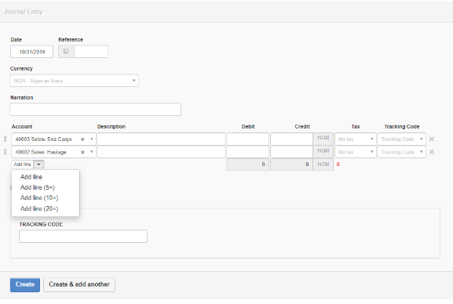

**Journal and Ledger Entry**

* Should be a module and can have restricted access. It will be the only way to input into the ledger.
* It will be a double entry book keeping.
* Can be printed and downloaded.
* The lines for input can be removed or moved around.
* The journal can have upto 20 lines view for input.
* Each line must have and account to allocated cost or expenses to. It can also be used to track projects/jobs,cost center,etc.
* It can be saved and edited. New journals can be created and option to add new will be indicated.
* It must show or highlight or notify you that or if the account is not balanced.
* The ledger entry periods can be selected for view over a period. 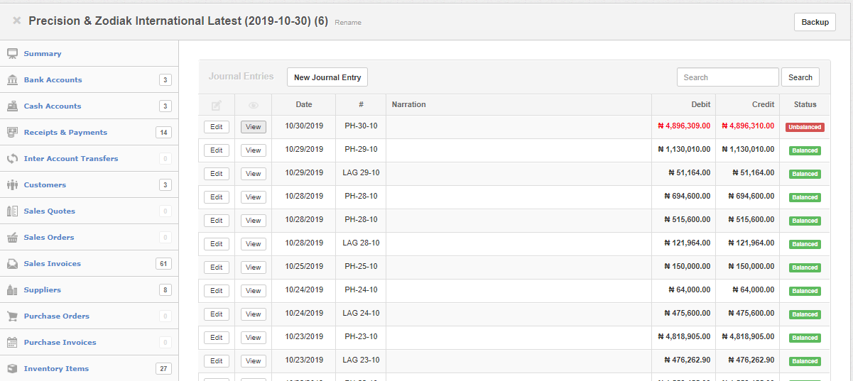
* The journal entry will have Date,reference ( could be manual or automatic) , Currebcy selection, Date,Etc.
* The journal list can have the buttons and forma similar. Or better , ther could be a table for such a function.
* 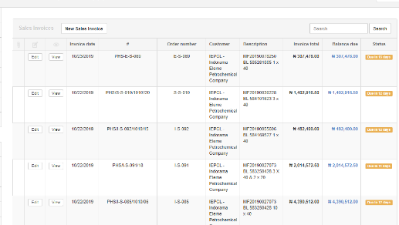There can be shipment ledger,client ledger,job or shipment ledger,branch ledger,etc

**Invoice**

* Some expenses can be marked automatically for invoicing on the invoice template with the details of the job of the job or account automatically registered . This is based on the fact that it is a job being executed for a client and will be reimbursed and services paid for. So for every ne job or shipment or contract, it will be recorded as such and that it will be invoiced.
* The invoices can be managed to show status ( no. of days due, paid, uninvoiced,queried,overdue,etc. ). The status can be defined by the admin section.
* 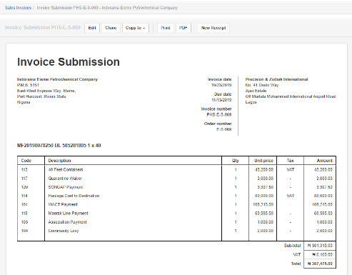A similar reference is listed above for your view and information. So once it is clicked on, it can take you to the invoice page for View or editing and other changes. Then is can be saved.
* The should be a payment receipt for invoices that has been paid so it can be transferred from account receivable to cash in the bank or cash at hand.
* Invoice can be duplicated,sent,downloaded,receipted ,edited.
* It can carry various details like invoice date,number,P.O. number,Client address,due date, signature, narrations or subject, comments and note section.
* The invoice should show the account being posted to,with quantity, and traceable to the job,shipment,cost centre,etc.
* 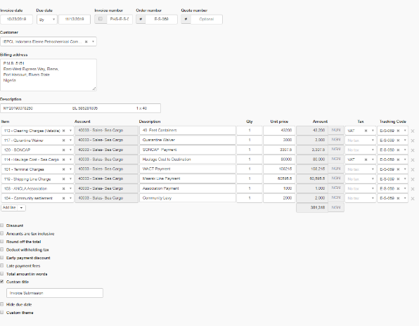The receipt should also show similar function of identifying the payment to the invoice or cost or expenses. This will help in profit and loss accounting.
* During invoicing, services being billed for can created and registeres so that during invoicing, you can just select from the drop down list or add more directly in a ädd new item”for quick and easy adding.

**Purchase Invoice, Sales,Quotation,Estimates,Invoices,**

* Sales order,quotation,Estimates, are all similar but the only difference will apply to the description as it suits the purpose. They all can be stored/archived,duplicated,printed,sent by mail as a link or attachement, they can be listed in a table with the same edit functions and view functions in their respective groups.
* Discounts,tax detailed as inclusive or not, and other standard features as you have in yours.

Purchase Order and Purchase Invoice

* Purchase orders and invoices would also be standard and have its reference.
* It can be edited,viewed, recorded, downloaded,printed etc.
* Multiple numbers can be listed similar to the sales invoice format.
* It will have the relevant data input like client address, Po Number ,reference number, etc.

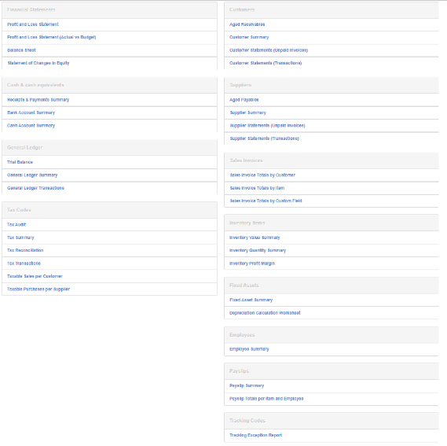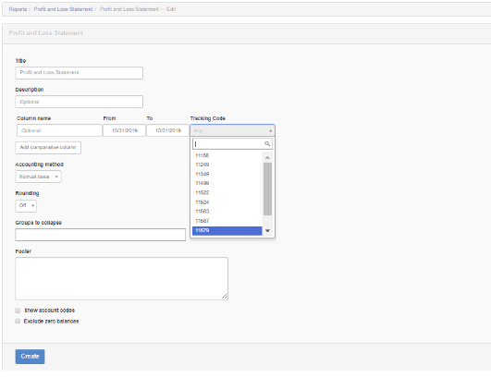

Reports:

* There would be many as similar to what you have on manager.io . I believe it is more of data selection or form generation based on existing information on the system. It may not be all, but you can select the once you need, there is also a way to make the report a customs report for easier and selection
* The profit and loss is very necessary for jobs and shipments so we can know performance for the job, shipment or selected account based on the unique reference.

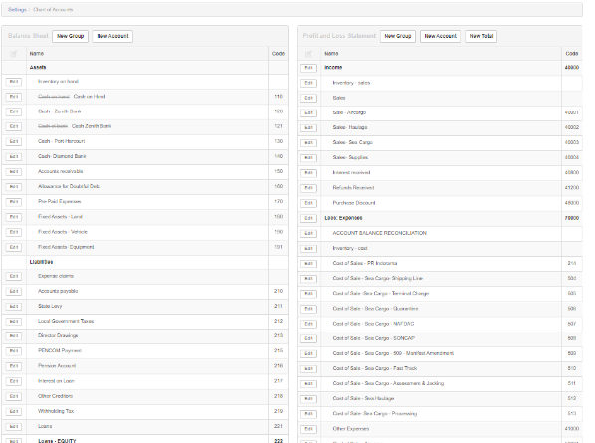

Chart Of Account

* The chart of account will have functions to label it by number or alphabets based on the standard balance sheet. ( Assets,liability,Equity ,Expenses,Income) So all the records on the chart would be recorded under these sections.
* It can be edited and viewed.

Modules:

Some modules are items that can be used as an add on. It Can be restricted to user account. Such modules are

Summary, Bank Account s, Chart of accounts, Cash account , Receipts and Payments, Inter account transfers, Customer account ,Sales order,Sale Quote,Sales estimations, Sale invoices ,suppliers, purchase orders, purchase invoice, journal, reports, employee, folders/documents, emails, settings, payslip,.

The permission would be View, create, update, delete.

Billable Expenses

This will have its on records for accounts that are refunded to staff for expenses incurred on behalf of the company. It can located or grouped by branch or account record and personel or purpose in the chart of account.

Billable Time

This will account for billable time to client based on hourly rate and amount and the paye. It could be invoiced to the client or by a staff to the company.

Other functions”:   
Credit Notes

Debit Notes

Inventory items

Inventory Write-off

Inventory transfer between offices

Fixed assets records and depreciation account/entries

Ability to upload documents for various payments, journals, entry and a general folder for docucments that may will have access limitation based on role given.

Receipts and payment records.

Bank Account details

Cash account .

Most of these are already in the account. What is left is just to give a form for the data to be presented as requested.